# Analysis of stop-and-frisk + camera locations in NYC

library(data.table)  
library(ggplot2)  
library(sf)  
library(units)  
library(geojsonsf)  
library(lme4)  
  
options(width=150)  
theme_set(theme_bw(base_size=16))

Linking to GEOS 3.8.0, GDAL 3.0.4, PROJ 6.3.1; sf_use_s2() is TRUE  
  
udunits database from /usr/share/xml/udunits/udunits2.xml  
  
Loading required package: Matrix

## 0. Data preparation and inspection

#### SOURCES

* Stop-and-frisk (SQF) data from NYPD, 2019 and 2020. <https://www1.nyc.gov/site/nypd/stats/reports-analysis/stopfrisk.page>
* Census data (demographics etc.) from the American Community Survey (ACS) 2014--2019, downloaded using the tidycensus package: <https://walker-data.com/tidycensus/articles/spatial-data.html>
* Census tract shapefiles 2019 from US Census: <https://www.census.gov/cgi-bin/geo/shapefiles/index.php?year=2019&layergroup=Census+Tracts> trimmed to the New York state shoreline: <http://gis.ny.gov/gisdata/inventories/details.cfm?DSID=927>
* Camera locations, as provided by Amnesty's "Decode Surveillance NYC" project

#### PREPARED DATASETS

* tracts: one row per census tract (excluding two entirely-aquatic census tracts, which have been removed). The shape of each tract is included. (All geo coordinates are in EPSG 2908, the State Plane Coordinate System for NY/LongIsland.)
* census: one row per census tract, excluding the two aquatic tracts
* sqf: one row per stop-and-frisk incident, spanning 2019 and 2020, labelled by census tract (except for four records in 2020 with nonsense locations, which have been removed)
* camera: one row per intersection, including geo coordinates
* camera_count: one row per census tract, giving the number of cameras by several different counting methods:
  + eff_cameras is the total area within the tract that is visible by public cameras (assuming a 120m radius), divided by the area seen by a camera.
  + eff_cameras_within_200m is the total area within 200m of the tract that is visible by public cameras, divided by the area seen by a camera.
  + cameras_within_200m is the total number of public cameras within 200m of the tract.
* With the latter two metrics, if there are two cameras in nearly the same spot, the total effective number of cameras is just one, since their areas overlap nearly completely. The idea behind this way of measuring surveillance is that if two cameras are in roughly the same spot it's most likely to cope with obstructed sightlines.

# Import and pre-process all the datasets  
source('prepdata.R')

To install your API key for use in future sessions, run this function with `install = TRUE`.  
  
Getting data from the 2015-2019 5-year ACS  
  
Warning message in eval(ei, envir):  
“Assigning 3 stops to nearest tract”

### DEMOGRAPHICS

# Population density, from census data  
  
df <- merge(tracts, census, by='GEOID', all.x=TRUE)  
df$area <- set_units(st_area(df), 'mile ^2')  
df$density <- df$popn / as.numeric(df$area)  
  
options(repr.plot.width=14, repr.plot.height=10)  
  
ggplot() +   
 geom_sf(data=df, aes(fill=ifelse(popn>250,pmin(density,120000),NA))) +  
 with(as.list(st_bbox(df)), coord_sf(xlim=c(xmin,xmax), ylim=c(ymin,ymax))) +  
 guides(fill=guide_colourbar(title='popn/mile^2')) +  
 ggtitle('Population density. Tracts with popn<=250 masked out') +  
 theme_bw(base_size=16) +  
 theme(panel.background = element_rect(fill='azure'))

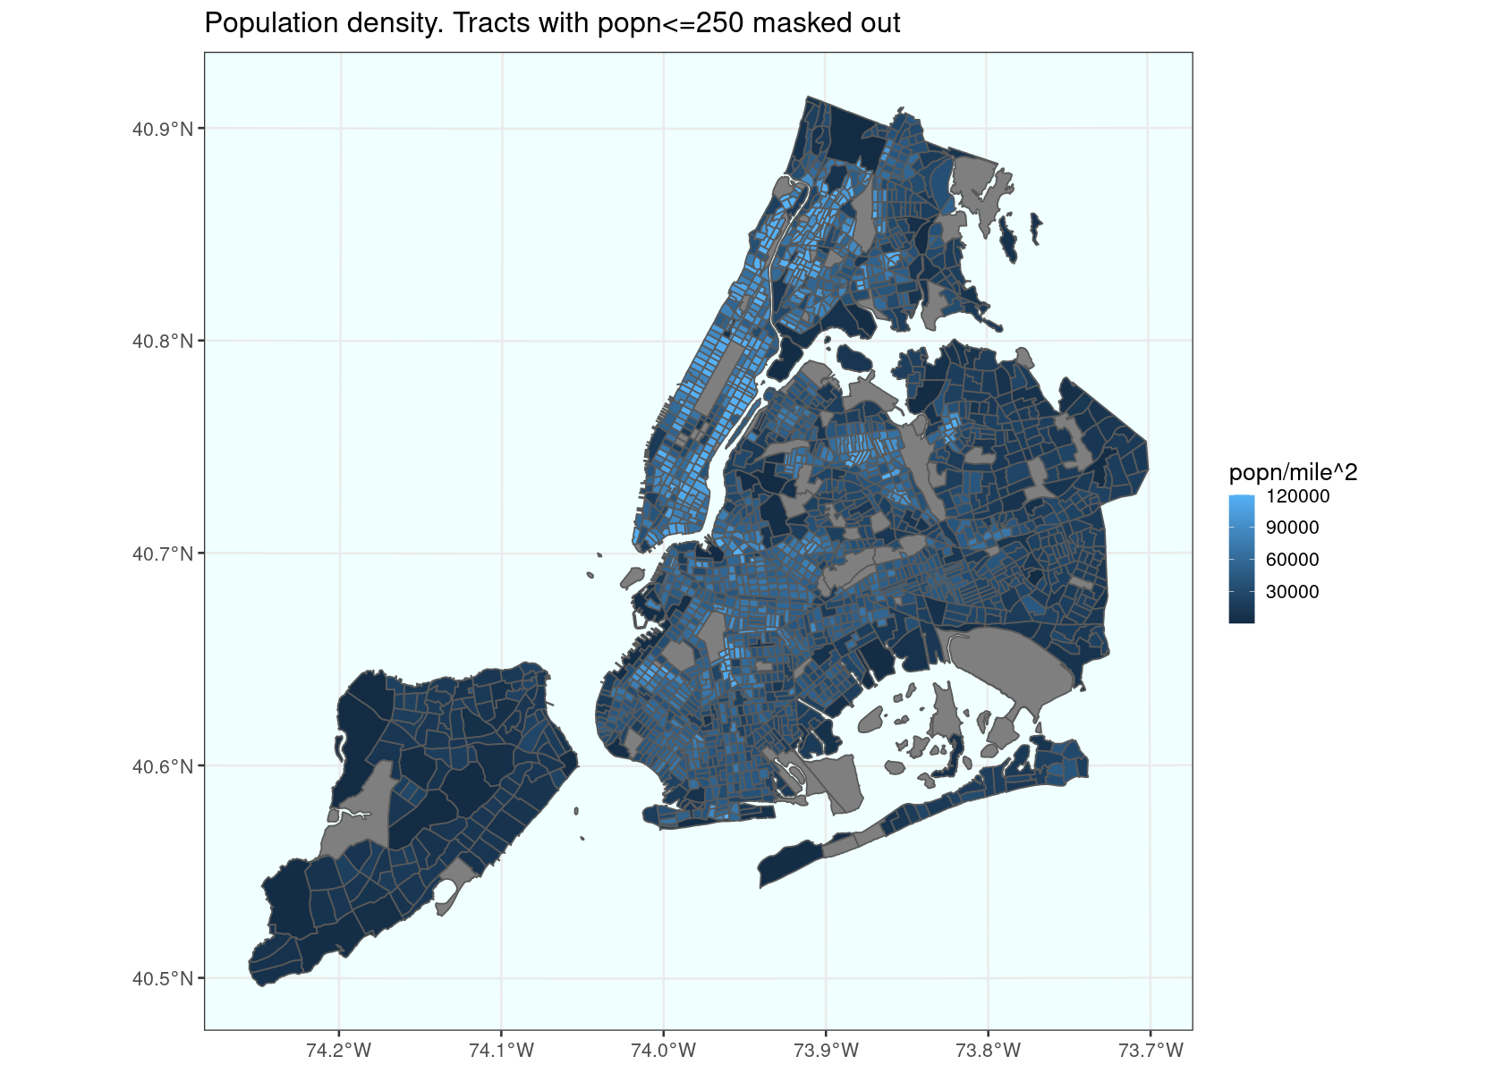

# Ethnic mix (black, hispanic, white)  
  
df <- merge(census, camera_count, by='GEOID', all=TRUE)  
df <- merge(df, as.data.table(st_drop_geometry(tracts))[, list(GEOID, borough)], by='GEOID', all=TRUE)  
  
# Colour-code by three-way split, Hispanic / Black / White.  
df[, popn2 := ifelse(popn>250, popn.black + popn.hispanic + popn.white, Inf)]  
λ.h <- df[, popn.hispanic / popn2]  
λ.w <- df[, popn.white / popn2]  
λ.b <- df[, popn.black / popn2]  
df[, ethcol := rgb(λ.h, λ.b, λ.w)]  
eth_guide <- df[c(which.max(λ.h), which.max(λ.b), which.max(λ.w))]  
eth_guide[, label := c('hispanic','black','white')]  
  
dft <- merge(tracts[,'GEOID'], df, by='GEOID')  
  
options(repr.plot.width=14, repr.plot.height=10)  
  
ggplot() +  
 geom_sf(data=dft, aes(fill=ifelse(popn>250,ethcol,'grey80')), col='grey80') +  
 scale_fill_identity(guide='legend', breaks=eth_guide$ethcol, labels=eth_guide$label) +  
 guides(fill=guide_legend(title='ethnic mix')) +  
 ggtitle('Ethnic mix (showing only Black/Hispanic/White)') +  
 theme_bw(base_size=16) +  
 theme(panel.background = element_rect(fill='azure'))

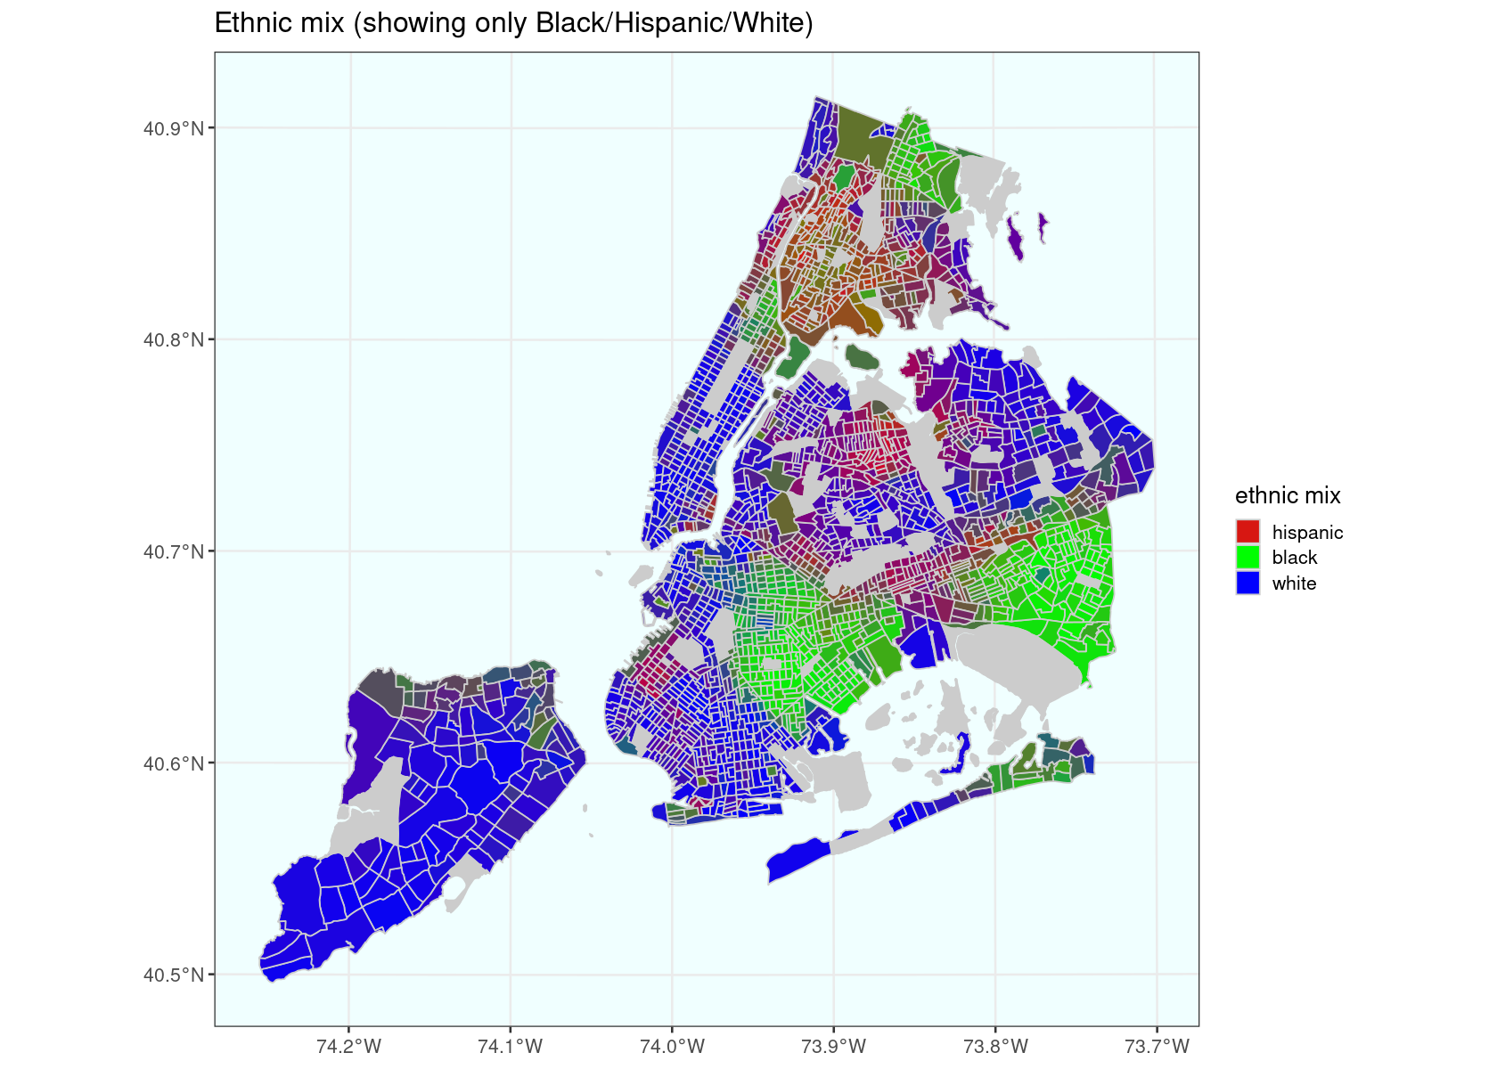

### STOP+FRISK

# Stop+frisk incidents  
  
options(repr.plot.width=14, repr.plot.height=10)  
  
ggplot() +   
 geom_sf(data=tracts, colour='bisque3', fill='bisque') +  
 geom_sf(data=BOROUGH, colour='black', fill=NA) +  
 geom_sf(data=sqf[sqf$YEAR2==2019,], aes(col=SUSPECT_RACE_DESCRIPTION), alpha=.2, size=1) +  
 with(as.list(st_bbox(sqf)), coord_sf(xlim=c(xmin,xmax), ylim=c(ymin,ymax))) +  
 guides(colour = guide_legend(override.aes=list(alpha=1, size=10))) +  
 ggtitle('Stop+frisk incidents in 2019') +  
 theme_bw(base_size=16) +  
 theme(panel.background = element_rect(fill='azure'))

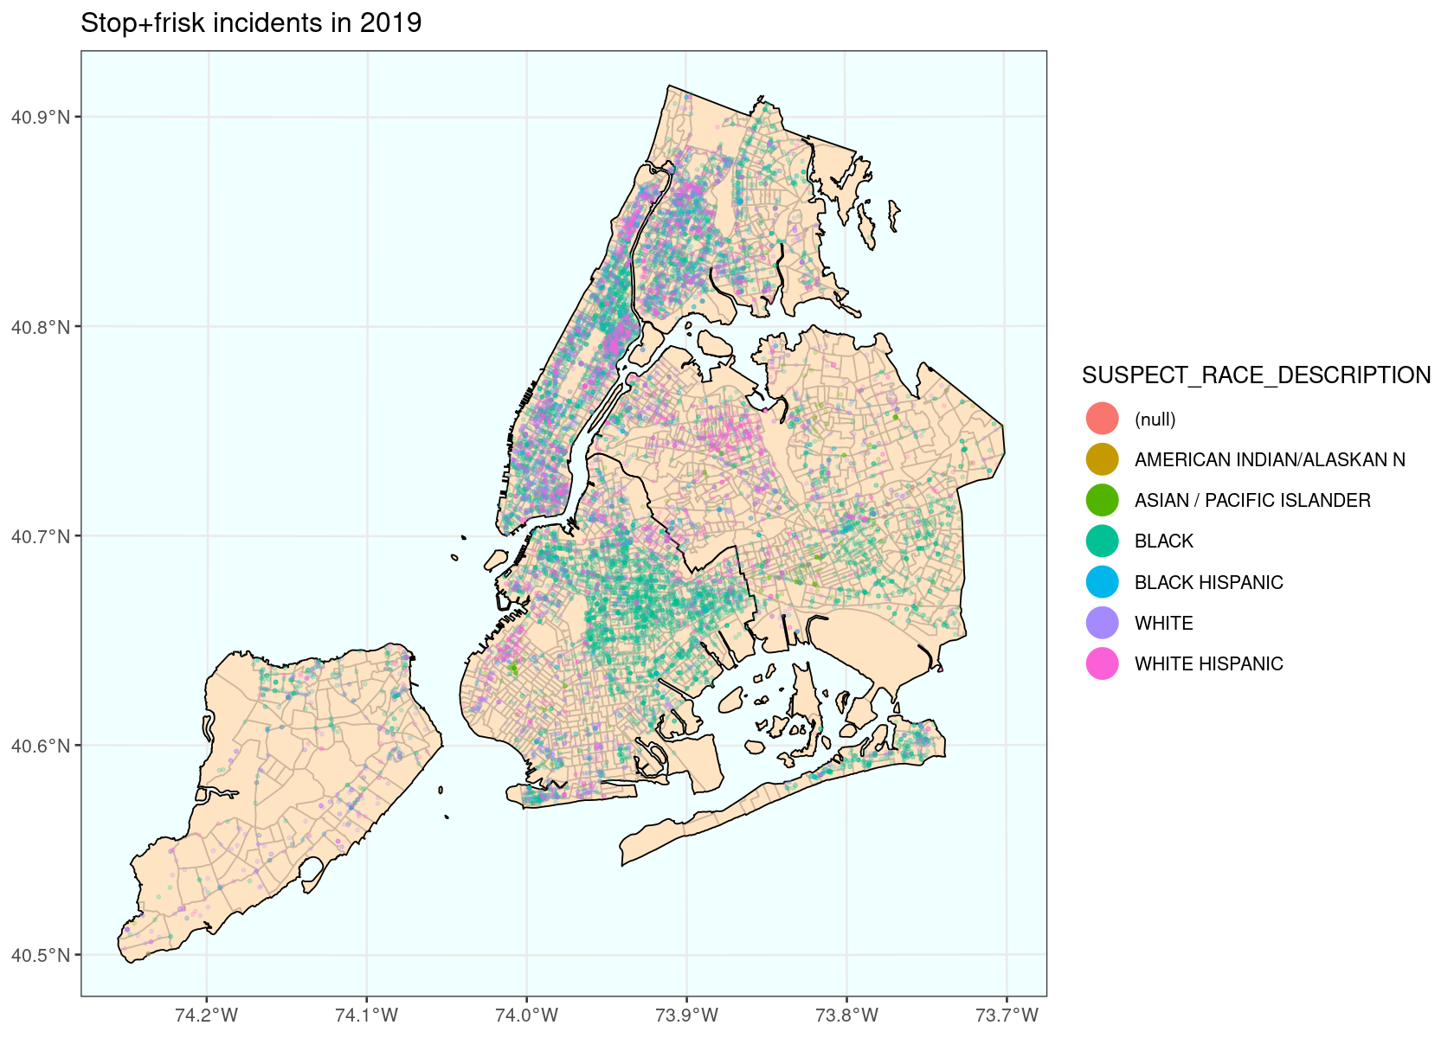

### SURVEILLANCE

# Public camera locations  
  
options(repr.plot.width=10.4, repr.plot.height=10)  
  
camera_coverage <- st_union(st_buffer(camera[camera$public,], dist=CAMERA_RADIUS))  
  
ggplot() +   
 geom_sf(data=tracts, colour='bisque3', fill='bisque') +  
 geom_sf(data=BOROUGH, colour='black', fill=NA) +  
 geom_sf(data=camera_coverage, fill='firebrick3', alpha=.4) +  
 with(as.list(st_bbox(sqf)), coord_sf(xlim=c(xmin,xmax), ylim=c(ymin,ymax))) +  
 ggtitle(paste('Public cameras with',format(CAMERA_RADIUS),'radius')) +  
 theme_bw(base_size=16) +  
 theme(panel.background=element_rect(fill='azure'))

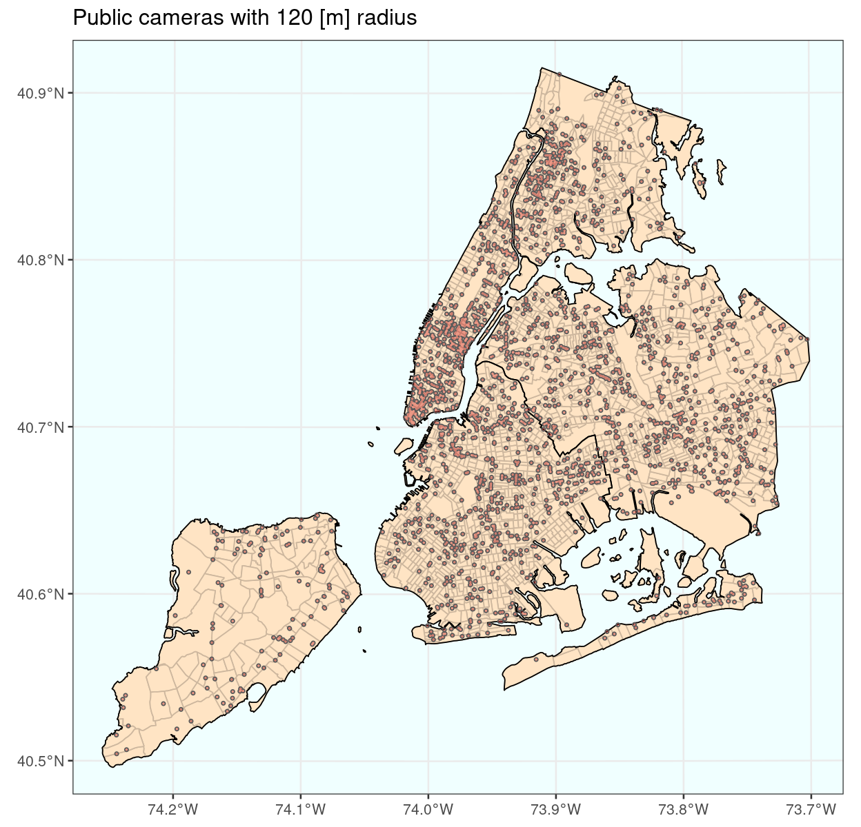

### SURVEILLANCE / POPULATION

# Which tracts have the highest surveillance levels?  
# (surveillance level = effective number of cameras per 1000 residents)  
# Only look at tracts with popn > 250, to exclude non-residential areas.  
  
df <- merge(census, camera_count, by='GEOID', all=TRUE)  
df[, surv := eff_cameras / popn * 1000]  
df[, surv_rank := rank(-surv), by=popn>250]  
df[, surv_class := ifelse(popn>250, ifelse(surv_rank<=20,'top20','other'), NA)]  
df <- merge(tracts[,c('GEOID','NAMELSAD','borough')], df, by='GEOID', all=TRUE)  
st_agr(df) <- 'constant'  
# Get a Google Maps url for the centroid of the tract  
df2 <- st_centroid(df[,'GEOID'])  
df2 <- st_transform(df2, crs='epsg:4326')  
df2 <- cbind(data.table(GEOID=df2$GEOID), st_coordinates(df2))  
df2[, url := paste0('http://maps.google.com/maps?z=12&t=m&q=loc:',Y,'+',X)]  
df <- merge(df, df2[, list(GEOID,url)], by='GEOID', all=TRUE)  
  
options(repr.plot.width=20.8, repr.plot.height=20)  
  
ggplot() +   
 geom_sf(data=df, aes(fill=surv_class), colour='bisque3') +  
 geom_sf(data=BOROUGH, colour='black', fill=NA) +  
 scale_fill_manual(values=c('top20'='red', 'other'='bisque2'), na.value='antiquewhite') +  
 with(as.list(st_bbox(sqf)), coord_sf(xlim=c(xmin,xmax), ylim=c(ymin,ymax))) +  
 ggtitle('Top 20 tracts with highest surveillance') +  
 theme_bw(base_size=16) +  
 theme(panel.background=element_rect(fill='azure'))

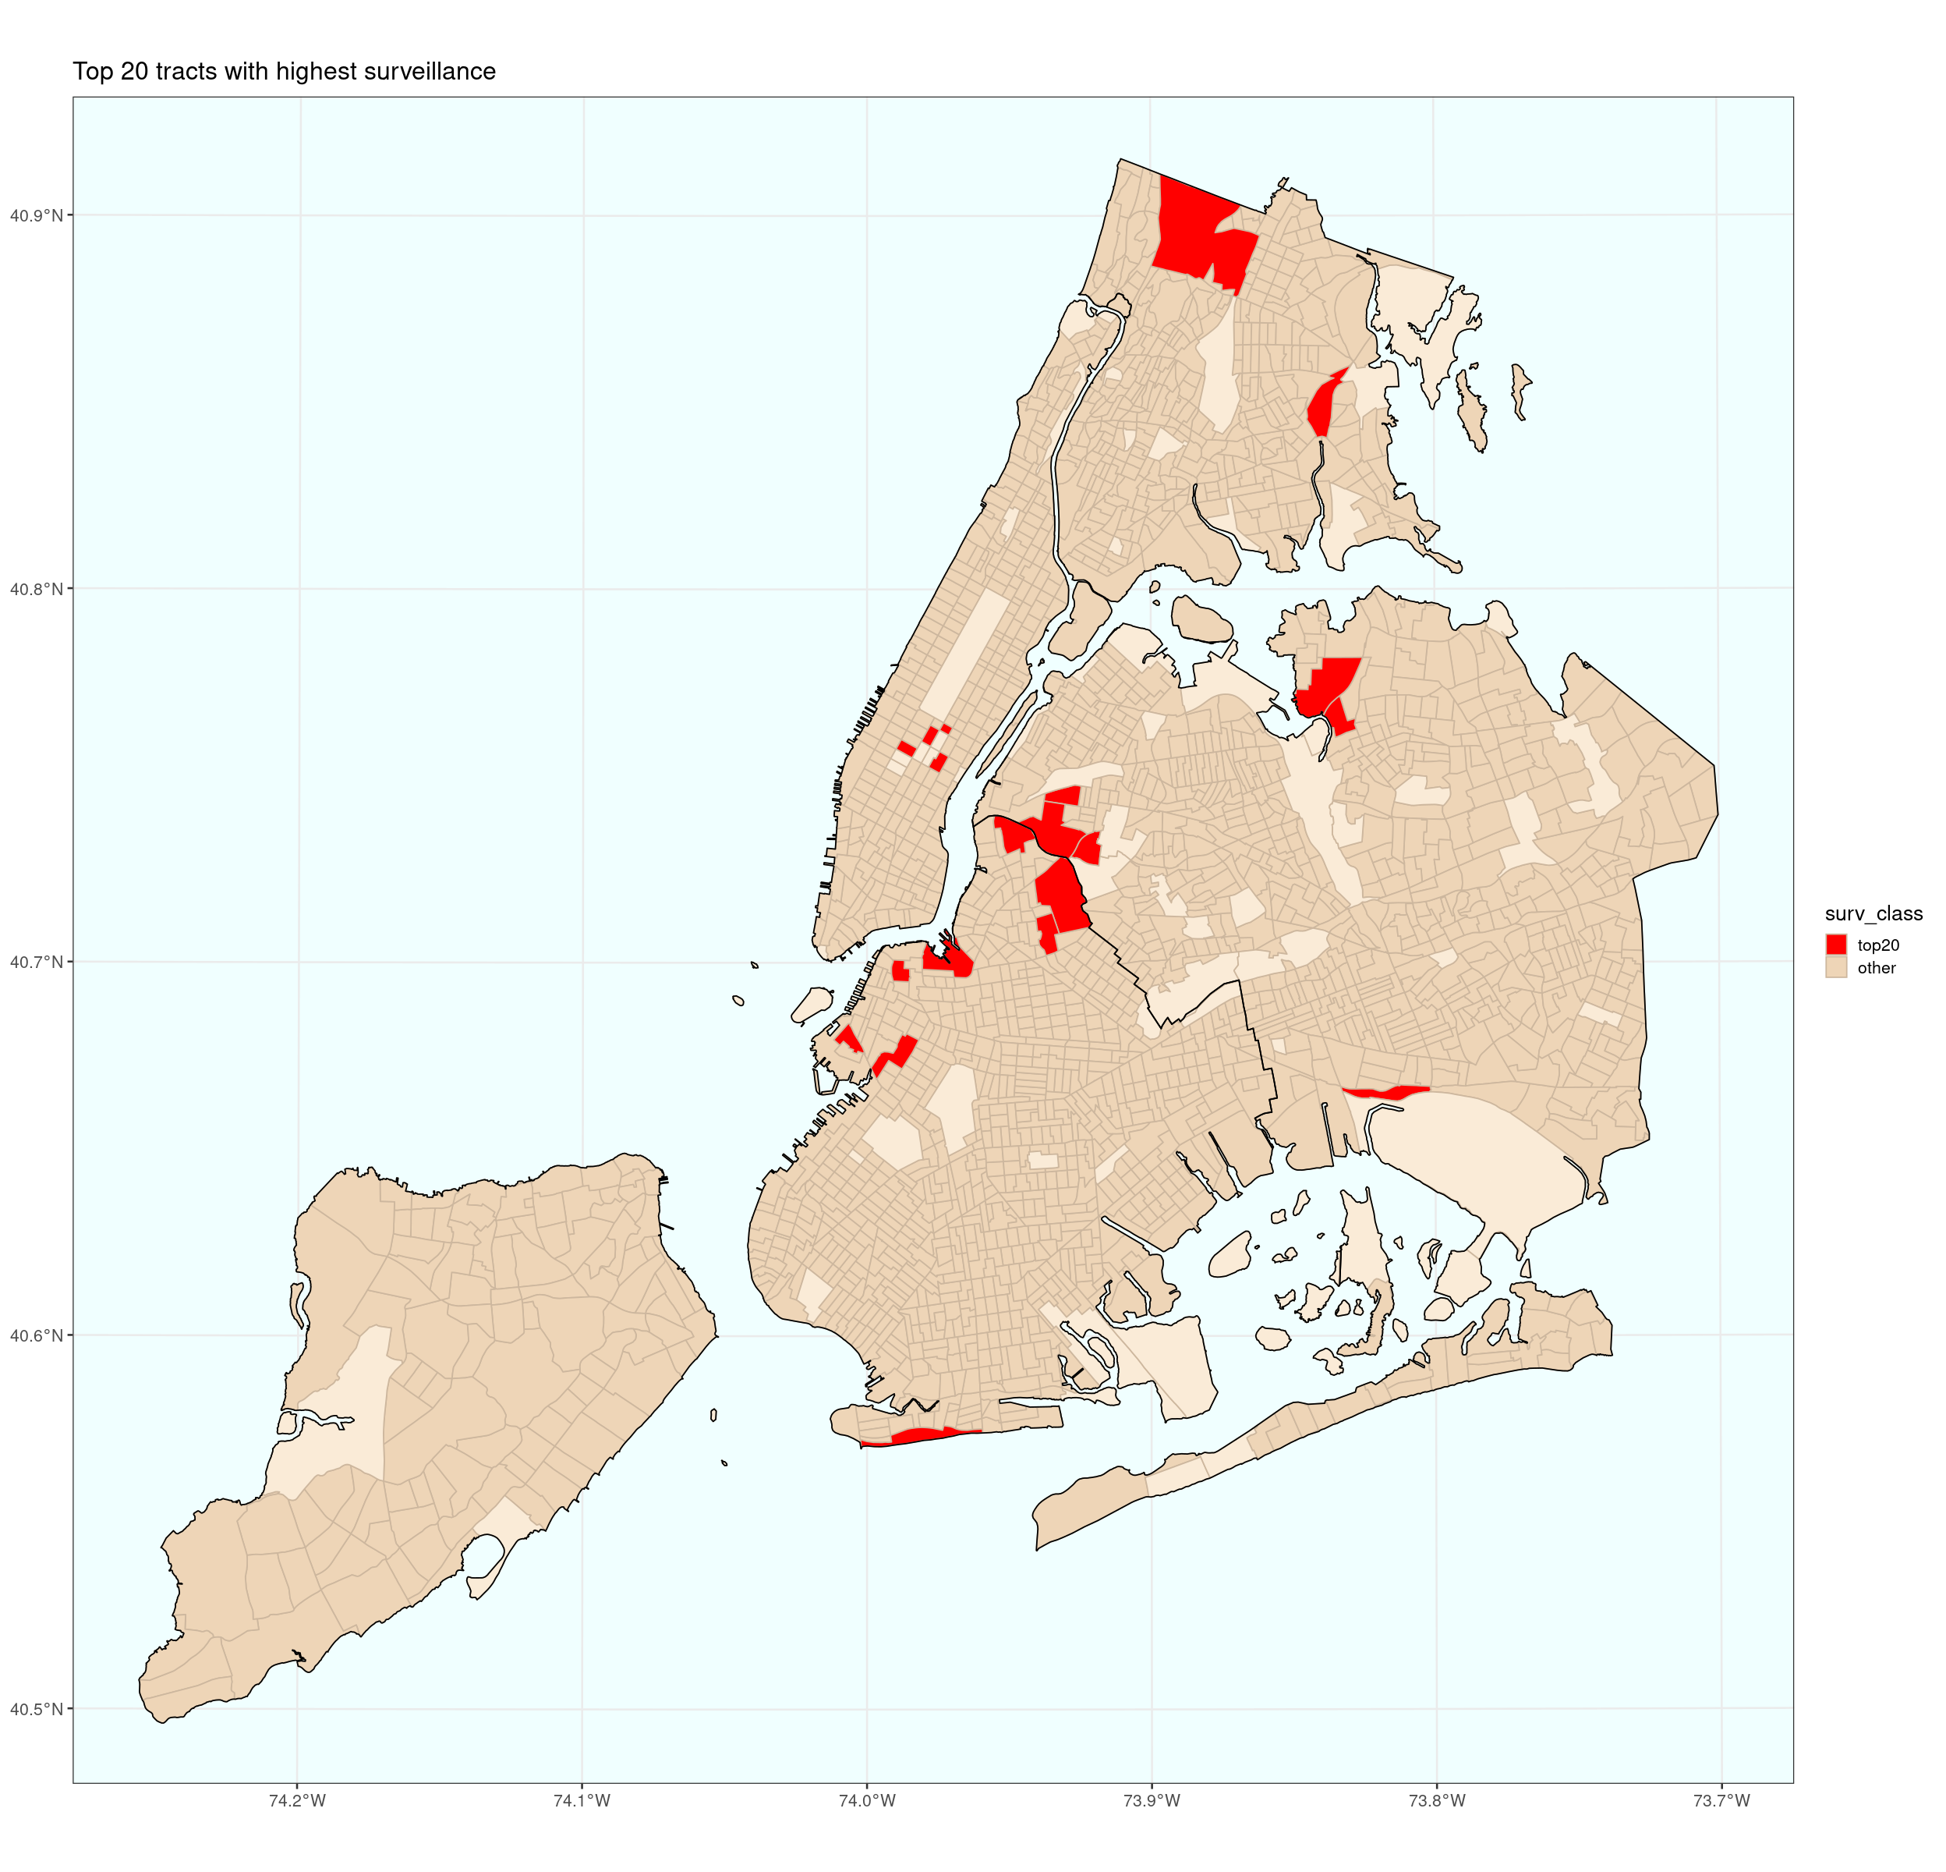

# The top 50 most surveilled census tracts (excluding those with popn <= 250)  
  
as.data.table(df)[popn>250 & surv_rank<=50][order(surv_rank), list(GEOID,NAMELSAD,borough,popn,eff_cameras,surv_rank,url)]

GEOID NAMELSAD borough popn eff_cameras surv_rank  
1 36047054300 Census Tract 543 Brooklyn 283 2.4232144 1   
2 36081019900 Census Tract 199 Queens 697 4.9148482 2   
3 36081017900 Census Tract 179 Queens 1019 4.7119249 3   
4 36061011202 Census Tract 112.02 Manhattan 415 1.6862763 4   
5 36081090700 Census Tract 907 Queens 1434 5.7624049 5   
6 36081084602 Census Tract 846.02 Queens 925 3.5133866 6   
7 36005028400 Census Tract 284 Bronx 554 1.5409576 7   
8 36047044900 Census Tract 449 Brooklyn 3210 8.9022172 8   
9 36061011900 Census Tract 119 Manhattan 1071 2.9550138 9   
10 36061010400 Census Tract 104 Manhattan 811 2.1815545 10   
11 36061009200 Census Tract 92 Manhattan 1474 3.9182786 11   
12 36047057900 Census Tract 579 Brooklyn 1165 3.0745038 12   
13 36005043500 Census Tract 435 Bronx 499 1.2030816 13   
14 36047011900 Census Tract 119 Brooklyn 1322 3.0205297 14   
15 36047035200 Census Tract 352 Brooklyn 1254 2.8244718 15   
16 36081086900 Census Tract 869 Queens 1771 3.8132589 16   
17 36081020500 Census Tract 205 Queens 1176 2.3714092 17   
18 36047005900 Census Tract 59 Brooklyn 1213 2.4192464 18   
19 36047001300 Census Tract 13 Brooklyn 1917 3.7913915 19   
20 36047048500 Census Tract 485 Brooklyn 2289 4.5043668 20   
21 36047109800 Census Tract 1098 Brooklyn 2359 4.3413446 21   
22 36061003700 Census Tract 37 Manhattan 2666 4.7583208 22   
23 36081008500 Census Tract 85 Queens 883 1.5557916 23   
24 36005006300 Census Tract 63 Bronx 4582 7.7866877 24   
25 36061000900 Census Tract 9 Manhattan 1796 2.9950564 25   
26 36005011700 Census Tract 117 Bronx 1443 2.3350008 26   
27 36047001800 Census Tract 18 Brooklyn 1897 3.0655438 27   
28 36061019701 Census Tract 197.01 Manhattan 639 1.0125440 28   
29 36081029300 Census Tract 293 Queens 1090 1.6693786 29   
30 36005001900 Census Tract 19 Bronx 3141 4.7729450 30   
31 36061004500 Census Tract 45 Manhattan 980 1.4861464 31   
32 36061011203 Census Tract 112.03 Manhattan 1103 1.6466061 32   
33 36061001300 Census Tract 13 Manhattan 4455 6.6253457 33   
34 36061003100 Census Tract 31 Manhattan 2525 3.6979451 34   
35 36061011401 Census Tract 114.01 Manhattan 1173 1.6631851 35   
36 36081020800 Census Tract 208 Queens 3136 4.3191795 36   
37 36081003300 Census Tract 33 Queens 3569 4.8857703 37   
38 36061010100 Census Tract 101 Manhattan 1373 1.8746598 38   
39 36047003500 Census Tract 35 Brooklyn 1907 2.5967407 39   
40 36061012500 Census Tract 125 Manhattan 2311 3.1256031 40   
41 36047036700 Census Tract 367 Brooklyn 1281 1.7225404 41   
42 36061010000 Census Tract 100 Manhattan 1741 2.3397171 42   
43 36047004700 Census Tract 47 Brooklyn 1877 2.4798944 43   
44 36047079400 Census Tract 794 Brooklyn 1716 2.2276285 44   
45 36081042600 Census Tract 426 Queens 477 0.6125966 45   
46 36081066300 Census Tract 663 Queens 2771 3.5518514 46   
47 36081148300 Census Tract 1483 Queens 2900 3.6298691 47   
48 36061009900 Census Tract 99 Manhattan 5981 7.3855809 48   
49 36081140901 Census Tract 1409.01 Queens 990 1.2021309 49   
50 36005028600 Census Tract 286 Bronx 1085 1.3108964 50   
 url   
1 http://maps.google.com/maps?z=12&t=m&q=loc:40.7009021108811+-73.9711860731856  
2 http://maps.google.com/maps?z=12&t=m&q=loc:40.7351969475049+-73.9340362079201  
3 http://maps.google.com/maps?z=12&t=m&q=loc:40.7446892921271+-73.9302772957279  
4 http://maps.google.com/maps?z=12&t=m&q=loc:40.7626039615687+-73.9721311338371  
5 http://maps.google.com/maps?z=12&t=m&q=loc:40.7742445733847+-73.8380630268819  
6 http://maps.google.com/maps?z=12&t=m&q=loc:40.6651262013001+-73.8165808751078  
7 http://maps.google.com/maps?z=12&t=m&q=loc:40.8494364375106+-73.8386905127224  
8 http://maps.google.com/maps?z=12&t=m&q=loc:40.717832474392+-73.9310189503987   
9 http://maps.google.com/maps?z=12&t=m&q=loc:40.7573151200653+-73.9860246553007  
10 http://maps.google.com/maps?z=12&t=m&q=loc:40.7607790857575+-73.9776728684315  
11 http://maps.google.com/maps?z=12&t=m&q=loc:40.7536475785273+-73.9747422230935  
12 http://maps.google.com/maps?z=12&t=m&q=loc:40.7343632301197+-73.9484579099195  
13 http://maps.google.com/maps?z=12&t=m&q=loc:40.8945006565832+-73.8819835591425  
14 http://maps.google.com/maps?z=12&t=m&q=loc:40.6753263429599+-73.9898082191175  
15 http://maps.google.com/maps?z=12&t=m&q=loc:40.5733064393004+-73.9812868769882  
16 http://maps.google.com/maps?z=12&t=m&q=loc:40.7653527115675+-73.8336673547186  
17 http://maps.google.com/maps?z=12&t=m&q=loc:40.7303893338009+-73.9218036203629  
18 http://maps.google.com/maps?z=12&t=m&q=loc:40.6794027860982+-74.0061192594526  
19 http://maps.google.com/maps?z=12&t=m&q=loc:40.6976149764291+-73.9883585864722  
20 http://maps.google.com/maps?z=12&t=m&q=loc:40.707839855891+-73.9363493490845   
21 http://maps.google.com/maps?z=12&t=m&q=loc:40.6526617235089+-73.9016506102304  
22 http://maps.google.com/maps?z=12&t=m&q=loc:40.726278095626+-74.0075034204877   
23 http://maps.google.com/maps?z=12&t=m&q=loc:40.7600215165174+-73.940722322593   
24 http://maps.google.com/maps?z=12&t=m&q=loc:40.8238506185581+-73.9283912087115  
25 http://maps.google.com/maps?z=12&t=m&q=loc:40.7023246877833+-74.0098565139476  
26 http://maps.google.com/maps?z=12&t=m&q=loc:40.8105018153381+-73.8766835274815  
27 http://maps.google.com/maps?z=12&t=m&q=loc:40.6553358361173+-74.0132794525594  
28 http://maps.google.com/maps?z=12&t=m&q=loc:40.80531104441+-73.9593993468251   
29 http://maps.google.com/maps?z=12&t=m&q=loc:40.7519326725642+-73.8994830070836  
30 http://maps.google.com/maps?z=12&t=m&q=loc:40.8030405682337+-73.9146080116714  
31 http://maps.google.com/maps?z=12&t=m&q=loc:40.7205701206259+-73.9993912050248  
32 http://maps.google.com/maps?z=12&t=m&q=loc:40.7612443989067+-73.9689142454845  
33 http://maps.google.com/maps?z=12&t=m&q=loc:40.7091259661897+-74.0129925082366  
34 http://maps.google.com/maps?z=12&t=m&q=loc:40.7153109519573+-74.0038150937813  
35 http://maps.google.com/maps?z=12&t=m&q=loc:40.7648402252091+-73.9704938939059  
36 http://maps.google.com/maps?z=12&t=m&q=loc:40.6983846475047+-73.8068861371267  
37 http://maps.google.com/maps?z=12&t=m&q=loc:40.75438447924+-73.9380995999987   
38 http://maps.google.com/maps?z=12&t=m&q=loc:40.7497314080164+-73.9915412167347  
39 http://maps.google.com/maps?z=12&t=m&q=loc:40.6853251969354+-73.9761802762101  
40 http://maps.google.com/maps?z=12&t=m&q=loc:40.7598407190052+-73.9841752446922  
41 http://maps.google.com/maps?z=12&t=m&q=loc:40.6775645923497+-73.9046130106438  
42 http://maps.google.com/maps?z=12&t=m&q=loc:40.7580652720345+-73.9712318119244  
43 http://maps.google.com/maps?z=12&t=m&q=loc:40.6883701898338+-74.0018565551786  
44 http://maps.google.com/maps?z=12&t=m&q=loc:40.648605301847+-73.9552860107495   
45 http://maps.google.com/maps?z=12&t=m&q=loc:40.6888726143057+-73.7702024656798  
46 http://maps.google.com/maps?z=12&t=m&q=loc:40.7211189613178+-73.8773457274675  
47 http://maps.google.com/maps?z=12&t=m&q=loc:40.7744932566264+-73.7492503275423  
48 http://maps.google.com/maps?z=12&t=m&q=loc:40.7520190332368+-74.0049130132931  
49 http://maps.google.com/maps?z=12&t=m&q=loc:40.7465404582977+-73.7749009383578  
50 http://maps.google.com/maps?z=12&t=m&q=loc:40.8491849054577+-73.8477751648193

## 1. The number of stop+frisk incidents is closely linked to the level of surveillance

We first analyze how the number of stop+frisk incidents depends on the number of cameras. The underlying statistical model we'll use is a generalized linear model,

$$\text{average num.stops in tract}=λ×\text{tract.popn}/1000,$$

Here $λ$ is the rate of stop+frisk incidents per 1000 population, and the focus of the analysis is to understand how λ depends on level of surveillance.

Furthermore, we'll model the actual number of stops as a Poisson random variable, with mean as specified above. This is a standard statistical model for analyzing count data.

We split the tracts into 9 groups, according to level of surveillance, and estimate λ separately for each group. (This allows us to assess the relationship between stop+frisk and surveillance, without assuming any particular form of the equation.) For this analysis, surveillance level is defined as the effective number of cameras within 200m of a given census tract, per 1000 residents. We see that the stop+frisk rate λ increases with the level of surveillance, and the relationship is roughly linear.

Our analysis uses data for 2019. We restrict attention to census tracts with a population of >250, as a simple way to exclude parks etc.

df <- as.data.table(expand.grid(GEOID=unique(census$GEOID), YEAR2=unique(sqf$YEAR2)))  
df <- merge(df, as.data.table(sqf)[, list(numstops=.N), by=list(GEOID,YEAR2)], all=TRUE) # numstops per tract,year  
df <- merge(df, census, by='GEOID', all=TRUE) # popn, popn.black, popn.hispanic, popn.white  
df <- merge(df, camera_count, by='GEOID', all=TRUE) # eff_cameras_within_200m and other counts  
df <- merge(df, as.data.table(st_drop_geometry(tracts))[, list(GEOID, borough)], by='GEOID', all=TRUE) # borough  
df[is.na(numstops), numstops := 0] # for the tracts with no recorded stops  
  
# Let stoprate = number of stops per 1000 residents in a census tract  
# Let surv by the effective number of cameras within 200m of the tract, per 1000 residents  
  
df[, stoprate := numstops/popn*1000]  
df[, surv := eff_cameras_within_200m/popn*1000]  
  
# For a non-parametric model, it's useful to split the tracts into separate groups  
# according to surveillance level. Let survF be a split version of surv.  
  
breaks <- c(seq(0,1.5,by=.25), 2, 3)  
break_midpoint <- c((tail(breaks,-1) + head(breaks,-1)) / 2, 3.5)  
df[, survF := cut(surv, breaks=c(breaks,Inf), labels=break_midpoint, include.lowest=TRUE)]  
breaks

[1] 0.00 0.25 0.50 0.75 1.00 1.25 1.50 2.00 3.00

# Estimate λ as a function of level of surveillance (using survF, our discretized version  
# of level-of-surveillance). The plot shows the estimates for λ as well as 95% confidence  
# intervals, for each surveillance level.  
  
fit <- glm(numstops ~ 0 + survF, offset=log(popn/1000),   
 data=df[popn>250 & YEAR2==2019],  
 family='poisson')  
x <- as.data.table(coef(summary(fit)))  
x[, stoprate := exp(Estimate)]  
x[, lo := exp(Estimate-1.96*`Std. Error`)]  
x[, hi := exp(Estimate+1.96*`Std. Error`)]  
x[,'survF' := levels(df$survF)]  
  
options(repr.plot.width=6, repr.plot.height=4)  
  
ggplot(data=x) +  
 geom_errorbar(aes(x=as.numeric(survF), ymin=lo, ymax=hi)) +  
 geom_line(aes(x=as.numeric(survF), y=stoprate), colour='red') +  
 xlab('surveillance level') + ylab('') +  
 ggtitle('Estimated stop+frisk per 1000 popn') +  
 coord_cartesian(ylim=c(1,3))

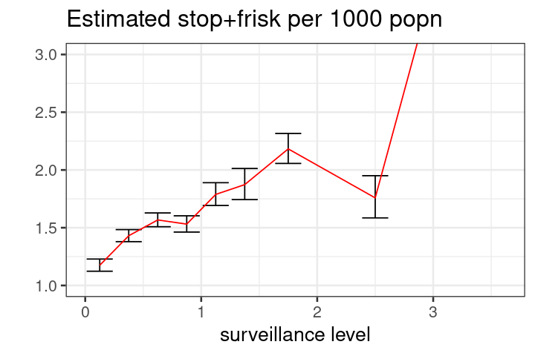

#### SANITY CHECKS

Here are some plots that support the underlying statistical model described above.

The first plot shows that the stop+frisk rate (number of stops per 1000 residents) grows with the surveillance level. This plot is very noisy.

The second and third plots show why there is so much noise. The actual number of stops in a given census tract is a small integer, mostly in the range 0-10, and so there is bound to be lots of noise in the data for a single census tract. The second plot supports the idea that the number of stop+frisk incidents is proportional to population, and the third plot is consistent with a Poisson model.

options(repr.plot.width=8, repr.plot.height=4)  
  
ggplot(data=df[popn>250 & YEAR2==2019], aes(y=numstops/popn*1000, x=eff_cameras_within_200m/popn*1000)) +  
 geom_point(aes(size=popn), alpha=.3) +  
 geom_smooth(method='loess', colour='red', formula=y~x) +  
 scale_size_area() +  
 coord_cartesian(xlim=c(0,4), ylim=c(0,5)) +  
 ggtitle('Stop rate (2019), as a function of surveillance')

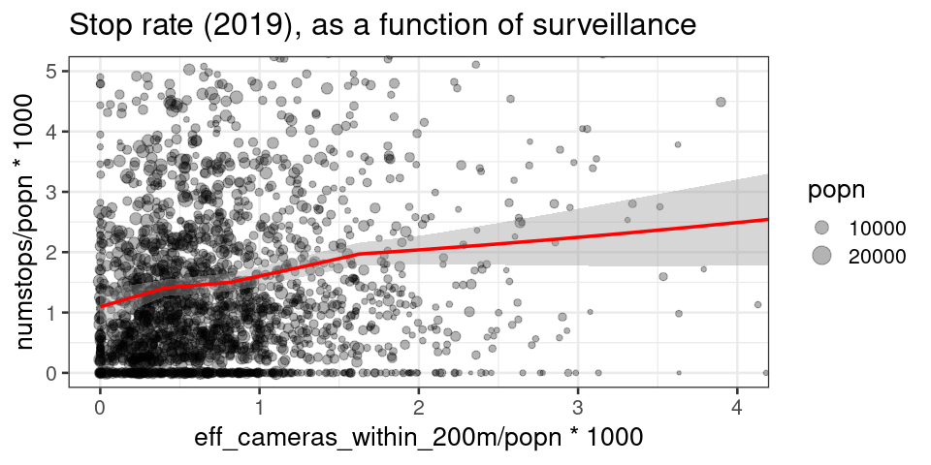

options(repr.plot.width=6, repr.plot.height=4)  
  
ggplot(data=df[popn>250 & YEAR2==2019], aes(x=popn, y=numstops)) +  
 geom_point(alpha=.5) +  
 geom_smooth(method='loess', colour='red', formula=y~x) +  
 coord_cartesian(xlim=c(0,15000), ylim=c(0,35))

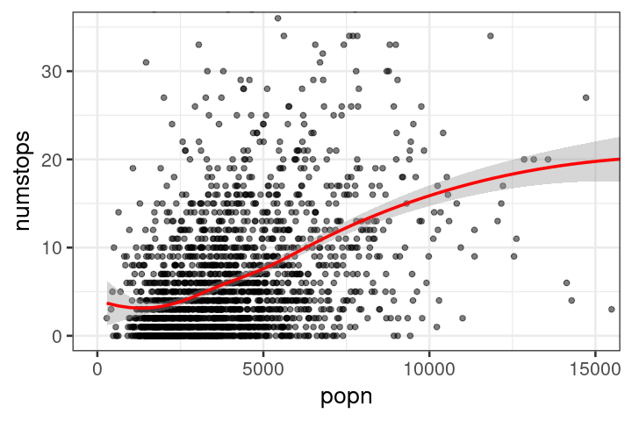

options(repr.plot.width=7, repr.plot.height=4)  
  
ggplot(data=df[YEAR2==2019]) +  
 geom_histogram(aes(x=numstops), colour='white', breaks=seq(-.5,40,by=1))

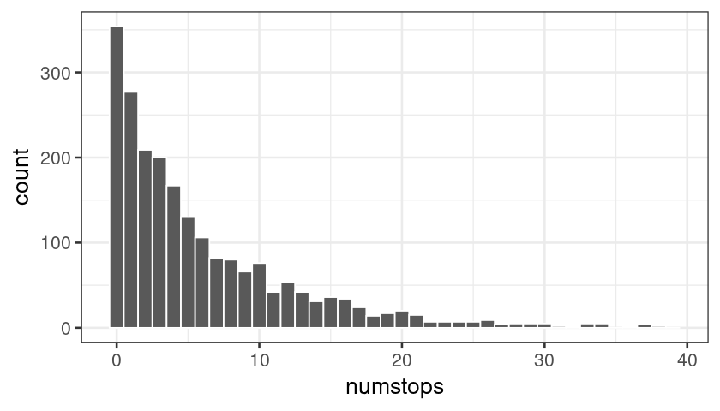

## 2. Stop+frisk rates also vary with racial mix, on top of the link to surveillance

What else does the stop+frisk rate depend on? As before we consider the model

$$\text{average num.stops in tract}=λ×\text{tract.popn}/1000$$

and we investigate what λ depends on. Our baseline model is a simple generalized linear model,

$$\text{log}λ=α+β×\text{surveillance.level}+γ×\text{nonwhite.fraction}$$

where α, β, γ, are coefficients to be estimated from the data.

Unsurprisingly, the coefficient for surveillance level (defined as effective number of cameras within 200m of the tract per 1000 residents) is positive, and highly significant (coef=0.02, p<0.001, for Queens in 2019).

The coefficient for nonwhite.fraction (defined as the fraction of residents who identify as Black or Hispanic, out of those who identify as Black or Hispanic or White) is also positive, and highly significant (coef=0.83, p<0.001, for Queens in 2019).

The β and γ coefficients vary from borough to borough, and they are consistent from 2019 to 2020. (See the chart below for the coefficient values and 95% confidence intervals.) They are consistently positive, and consistently significant.

The fact that both β and γ are highly significant shows that they are not confounding each other. In other words, it is *not* the case that variation in stop+frisk due to surveillance level is entirely explained by the racial mix.

#### SANITY CHECKS

We developed the baseline model using data from a single borough (Queens), to avoid overfitting.

* We tested for a non-linear dependence on surveillance level, but it is not significant.
* We also tested a model with separate coefficients for black.fraction and hispanic.fraction, but the difference between these coefficients is not significant. For all our analyses below, we have therefore pooled Black and Hispanic populations.
* We also tested for an interaction between surveillance.level and nonwhite.fraction. It was not significant. (We might expect we'd need more data to estimate an interaction effect, so we also tried pooling four boroughs excluding Manhattan, and also pooling all five boroughs. It remains not significant in both cases.)

df <- as.data.table(expand.grid(GEOID=unique(census$GEOID), YEAR2=unique(sqf$YEAR2)))  
df <- merge(df, as.data.table(sqf)[, list(numstops=.N), by=list(GEOID,YEAR2)], all=TRUE) # numstops per tract,year  
df <- merge(df, census, by='GEOID', all=TRUE) # popn, popn.black, popn.hispanic, popn.white  
df <- merge(df, camera_count, by='GEOID', all=TRUE) # eff_cameras_within_200m and other counts  
df <- merge(df, as.data.table(st_drop_geometry(tracts))[, list(GEOID, borough)], by='GEOID', all=TRUE) # borough  
df[is.na(numstops), numstops := 0] # for the tracts with no recorded stops  
  
# Let stoprate = number of stops per 1000 residents in a census tract  
# Let surv by the effective number of cameras within 200m of the tract, per 1000 residents  
  
df[, stoprate := numstops/popn*1000]  
df[, surv := eff_cameras_within_200m/popn*1000]  
df[, nonwhite_fraction := (popn.black + popn.hispanic) / (popn.black + popn.hispanic + popn.white)]

# The baseline model  
fit0 <- glm(numstops ~ surv + nonwhite_fraction, offset=log(popn),   
 family='poisson',  
 data=df[YEAR2==2019 & borough=='Queens'],  
 subset=popn>250)

# Baseline model sanity check. Is it reasonable to assume a linear dependence on surv?  
# Is it reasonable to pool Black and Hispanic?  
  
fit1 <- update(fit0, . ~ . + I(surv^2) + I(popn.black/popn))  
summary(fit1)

Call:  
glm(formula = numstops ~ surv + nonwhite_fraction + I(surv^2) +   
 I(popn.black/popn), family = "poisson", data = df[YEAR2 ==   
 2019 & borough == "Queens"], subset = popn > 250, offset = log(popn))  
  
Deviance Residuals:   
 Min 1Q Median 3Q Max   
-3.7321 -1.6934 -0.5816 0.6344 7.4685   
  
Coefficients:  
 Estimate Std. Error z value Pr(>|z|)   
(Intercept) -7.538773 0.065070 -115.856 < 2e-16 ***  
surv 0.204248 0.035519 5.750 8.90e-09 ***  
nonwhite_fraction 0.832449 0.116499 7.146 8.96e-13 ***  
I(surv^2) -0.004956 0.003158 -1.569 0.117   
I(popn.black/popn) 0.087239 0.099152 0.880 0.379   
---  
Signif. codes: 0 ‘***’ 0.001 ‘**’ 0.01 ‘*’ 0.05 ‘.’ 0.1 ‘ ’ 1  
  
(Dispersion parameter for poisson family taken to be 1)  
  
 Null deviance: 2267.1 on 640 degrees of freedom  
Residual deviance: 2037.0 on 636 degrees of freedom  
AIC: 3614.9  
  
Number of Fisher Scoring iterations: 5

# Further sanity check. Is there any interaction between the surveillance term and the nonwhite_fraction?  
# We'll use a simple binarized version of nonwhite_fraction -- it's more robust to explore the question  
# non-parametrically in the first instance, than to assume a formula.  
  
df[, nwfC := cut(nonwhite_fraction, breaks=2)]  
  
fit <- lm(stoprate ~ nwfC*surv,  
 weight=popn,  
 data=df,  
 subset=popn>250 & YEAR2==2019 & borough!='Manhattan')  
summary(fit)

Call:  
lm(formula = stoprate ~ nwfC * surv, data = df, subset = popn >   
 250 & YEAR2 == 2019 & borough != "Manhattan", weights = popn)  
  
Weighted Residuals:  
 Min 1Q Median 3Q Max   
-174.08 -51.15 -19.24 28.41 831.22   
  
Coefficients:  
 Estimate Std. Error t value Pr(>|t|)   
(Intercept) 0.52090 0.07330 7.106 1.71e-12 ***  
nwfC(0.5,1] 0.83911 0.09913 8.465 < 2e-16 ***  
surv 0.52639 0.07327 7.185 9.78e-13 ***  
nwfC(0.5,1]:surv 0.04881 0.09851 0.495 0.62   
---  
Signif. codes: 0 ‘***’ 0.001 ‘**’ 0.01 ‘*’ 0.05 ‘.’ 0.1 ‘ ’ 1  
  
Residual standard error: 87.59 on 1823 degrees of freedom  
Multiple R-squared: 0.1434, Adjusted R-squared: 0.142   
F-statistic: 101.7 on 3 and 1823 DF, p-value: < 2.2e-16

# How do the coefficients vary from year to year, and borough to borough?  
  
resdf <- as.data.table(expand.grid(YEAR2=unique(df$YEAR2), borough=unique(df$borough)))  
  
resdf <- mapply(resdf$YEAR2, resdf$borough, SIMPLIFY=FALSE, FUN=function(y,b) {  
 fit <- update(fit0, data=df[YEAR2==y & borough==b])  
 x <- coef(summary(fit))  
 data.table(YEAR2=y, borough=b, coef=dimnames(x)[[1]], Estimate=x[,'Estimate'], se=x[,'Std. Error'])  
})  
resdf <- do.call(rbind, resdf)  
resdf[, year := factor(YEAR2)]  
  
options(repr.plot.width=14, repr.plot.height=5)  
  
ggplot(data=resdf[coef!='(Intercept)']) +   
 geom_vline(xintercept=0, size=1, color='black') +  
 geom_errorbarh(aes(xmin=Estimate-1.96*se, xmax=Estimate+1.96*se, y=borough,col=year), position=position_dodge(0.3)) +  
 geom_point(aes(x=Estimate, y=borough, col=year), position=position_dodge(0.3)) +   
 facet_wrap(~coef, scales='free_x') +  
 theme_bw() + theme(text=element_text(size=20)) +  
 ggtitle('Coefficient estimates (with 95% confint)') +  
 xlab('coefficient of increased stoprate')

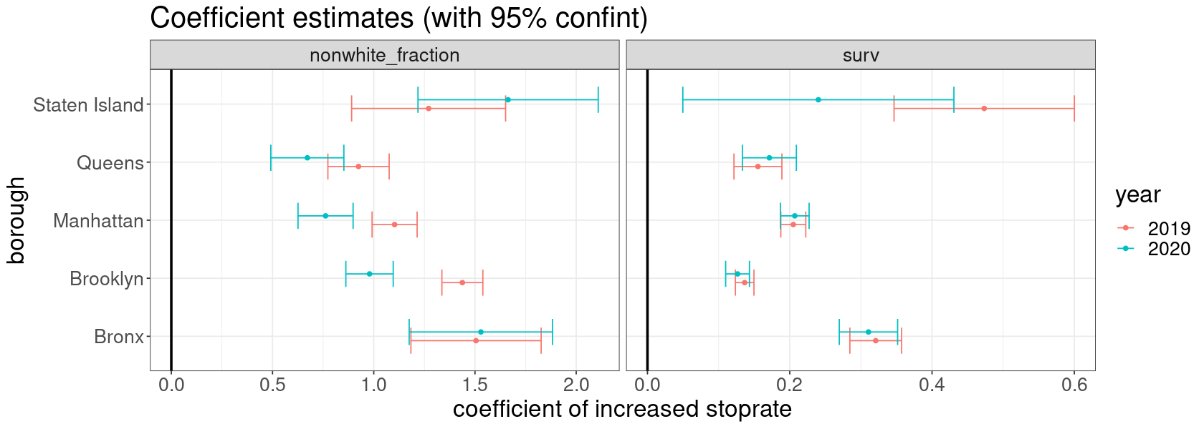

## 3. How does surveillance depend on demographics etc.?

We have seen that stop+frisk rates depend separately on surveillance level and on the proportion of nonwhite residents. We now investigate what surveillance level depends on.

For these analyses we'll measure surveillance level by effective number of cameras per 1000 residents in a census tract. As before we assign each camera a radius of 120m, and we measure the total area visible, then divide by the area visible by a single camera. In this section we're analysing the attributes of each area of the city, so we'll measure the area surveilled within each census tract (eff_cameras/popn). This in contrast to the earlier analyses of stop+frisk counts, where we analysed the attributes of residents, and we measured the area surveilled within a neighbourhood of the census tract (eff_cameras_within_200m/popn).

* In Manhatten, the higher nonwhite_fraction, the lower the level of surveillance (p<0.001).
* In Bronx (p=0.053), Brooklyn (p=0.027), and Queens (p=0.015), the higher the nonwhite_fraction, the higher the level of surveillance
* In Staten Island, no significant relationship (p=0.082).

When we take accout of poverty (. ~ . + borough:med.income), the findings point in the same direction, though they are less significant. This suggests there is some degree of confounding, since there is more poverty linked with greater proportion of nonwhite residents.

Manhattan is most likely a special case: it's a transport hub, so there are many non-resident occupants, and policing e.g. surveillance may well be linked to the number of occupants rather than residents.

#### MODEL CHOICE

The analyses are based on logistic regression. Surveillance level is most definitely non-Gaussian (it's truncated at zero -- see the histogram below), so it's not sound to fit a linear regression. Instead, we have binarized it into low versus high, with a threshold of 0.18 cameras per 1000 residents (close to the median). This is a simple way to get robust results.

Our baseline model is

$$\text{logit}\text{Prob}(\text{high})=α_{\text{borough}}+β_{\text{borough}}×\text{nonwhite_fraction}$$

and we are interested in the β coefficients, one for each borough.

df <- merge(census, camera_count, by='GEOID', all=TRUE)  
df <- merge(df, as.data.table(st_drop_geometry(tracts))[, list(GEOID, borough)], by='GEOID', all=TRUE)  
df[, nonwhite_fraction := (popn.black + popn.hispanic) / (popn.black + popn.hispanic + popn.white)]  
df[, surv := eff_cameras / popn * 1000]  
df[, survF := ifelse(surv < quantile(surv, 2/3, na.rm=TRUE), 'low', 'high')]  
  
SURV_THRESHOLD <- 0.2

# The baseline model  
  
fit <- glm(surv > SURV_THRESHOLD ~ 0 + borough + borough:nonwhite_fraction,   
 data=df, subset=popn>250,  
 family='binomial')  
summary(fit)

Call:  
glm(formula = surv > SURV_THRESHOLD ~ 0 + borough + borough:nonwhite_fraction,   
 family = "binomial", data = df, subset = popn > 250)  
  
Deviance Residuals:   
 Min 1Q Median 3Q Max   
-1.5946 -1.0872 -0.8329 1.1893 1.8189   
  
Coefficients:  
 Estimate Std. Error z value Pr(>|z|)   
boroughBronx -1.6062 0.5452 -2.946 0.00321 **   
boroughBrooklyn -0.5881 0.1384 -4.249 2.15e-05 ***  
boroughManhattan 0.3219 0.2016 1.597 0.11025   
boroughQueens -0.1307 0.1747 -0.748 0.45419   
boroughStaten Island -0.3403 0.3307 -1.029 0.30348   
boroughBronx:nonwhite_fraction 1.2966 0.6702 1.935 0.05301 .   
boroughBrooklyn:nonwhite_fraction 0.5029 0.2268 2.217 0.02662 *   
boroughManhattan:nonwhite_fraction -1.7864 0.4529 -3.944 8.00e-05 ***  
boroughQueens:nonwhite_fraction 0.6958 0.2873 2.422 0.01545 *   
boroughStaten Island:nonwhite_fraction 1.6749 0.9642 1.737 0.08236 .   
---  
Signif. codes: 0 ‘***’ 0.001 ‘**’ 0.01 ‘*’ 0.05 ‘.’ 0.1 ‘ ’ 1  
  
(Dispersion parameter for binomial family taken to be 1)  
  
 Null deviance: 2914.0 on 2102 degrees of freedom  
Residual deviance: 2814.2 on 2092 degrees of freedom  
AIC: 2834.2  
  
Number of Fisher Scoring iterations: 4

# What if surveillance is related to poverty levels instead?  
# Doesn't look like it.  
  
fit2 <- update(fit, . ~ . + med.income)  
summary(fit2)

Call:  
glm(formula = surv > SURV_THRESHOLD ~ borough + med.income +   
 borough:nonwhite_fraction - 1, family = "binomial", data = df,   
 subset = popn > 250)  
  
Deviance Residuals:   
 Min 1Q Median 3Q Max   
-1.5694 -1.0901 -0.8293 1.1998 1.8380   
  
Coefficients:  
 Estimate Std. Error z value Pr(>|z|)   
boroughBronx -1.504e+00 5.929e-01 -2.537 0.011177 *   
boroughBrooklyn -4.437e-01 2.076e-01 -2.137 0.032564 *   
boroughManhattan 5.941e-01 3.496e-01 1.699 0.089305 .   
boroughQueens 1.157e-02 2.299e-01 0.050 0.959853   
boroughStaten Island -1.356e-01 3.857e-01 -0.352 0.725108   
med.income -1.746e-06 1.810e-06 -0.965 0.334749   
boroughBronx:nonwhite_fraction 1.270e+00 7.014e-01 1.811 0.070181 .   
boroughBrooklyn:nonwhite_fraction 4.358e-01 2.363e-01 1.845 0.065108 .   
boroughManhattan:nonwhite_fraction -2.038e+00 5.357e-01 -3.804 0.000142 ***  
boroughQueens:nonwhite_fraction 6.659e-01 2.885e-01 2.308 0.020982 *   
boroughStaten Island:nonwhite_fraction 1.412e+00 9.828e-01 1.437 0.150747   
---  
Signif. codes: 0 ‘***’ 0.001 ‘**’ 0.01 ‘*’ 0.05 ‘.’ 0.1 ‘ ’ 1  
  
(Dispersion parameter for binomial family taken to be 1)  
  
 Null deviance: 2898.7 on 2091 degrees of freedom  
Residual deviance: 2799.2 on 2080 degrees of freedom  
 (11 observations deleted due to missingness)  
AIC: 2821.2  
  
Number of Fisher Scoring iterations: 4

# We should consider unpacking %non-white into black & hispanic.  
# As before, there's no signficant difference.  
  
fit3 <- update(fit, . ~ . + I((popn.black - popn.hispanic)/popn))  
summary(fit3)

Call:  
glm(formula = surv > SURV_THRESHOLD ~ borough + I((popn.black -   
 popn.hispanic)/popn) + borough:nonwhite_fraction - 1, family = "binomial",   
 data = df, subset = popn > 250)  
  
Deviance Residuals:   
 Min 1Q Median 3Q Max   
-1.6017 -1.0849 -0.8297 1.1824 1.8063   
  
Coefficients:  
 Estimate Std. Error z value Pr(>|z|)   
boroughBronx -1.57222 0.54729 -2.873 0.00407 **   
boroughBrooklyn -0.56567 0.14415 -3.924 8.70e-05 ***  
boroughManhattan 0.32716 0.20178 1.621 0.10493   
boroughQueens -0.09321 0.18748 -0.497 0.61905   
boroughStaten Island -0.33022 0.33120 -0.997 0.31874   
I((popn.black - popn.hispanic)/popn) 0.08104 0.14687 0.552 0.58110   
boroughBronx:nonwhite_fraction 1.27483 0.66973 1.903 0.05698 .   
boroughBrooklyn:nonwhite_fraction 0.43643 0.25669 1.700 0.08909 .   
boroughManhattan:nonwhite_fraction -1.78229 0.45263 -3.938 8.23e-05 ***  
boroughQueens:nonwhite_fraction 0.63678 0.30684 2.075 0.03796 *   
boroughStaten Island:nonwhite_fraction 1.66227 0.96501 1.723 0.08497 .   
---  
Signif. codes: 0 ‘***’ 0.001 ‘**’ 0.01 ‘*’ 0.05 ‘.’ 0.1 ‘ ’ 1  
  
(Dispersion parameter for binomial family taken to be 1)  
  
 Null deviance: 2914.0 on 2102 degrees of freedom  
Residual deviance: 2813.9 on 2091 degrees of freedom  
AIC: 2835.9  
  
Number of Fisher Scoring iterations: 4

### SANITY CHECKS AND DATA PLOTS

# Does the raw data support the link between nonwhite_fraction and higher surveillance?  
# In Manhattan, it's abundantly obvious.  
# In other boroughs, possibly yes, but it's a small signal and so it's not surprising  
# we need formal statistics to pull it out.  
  
options(repr.plot.width=7, repr.plot.height=12)  
  
ggplot(data=df[popn>250], aes(x=(popn.black + popn.hispanic) / (popn.black + popn.hispanic + popn.white), y=surv)) +   
 geom_point(aes(size=popn), alpha=.4) +  
 geom_smooth(method='loess', col='red', size=2, formula=y~x) +  
 facet_grid(borough~.) +  
 scale_size_area() +  
 coord_cartesian(ylim=c(0,.8)) +  
 theme_bw(base_size=16) +  
 xlab('% black or hispanic') + ylab('cameras per 1000 residents')

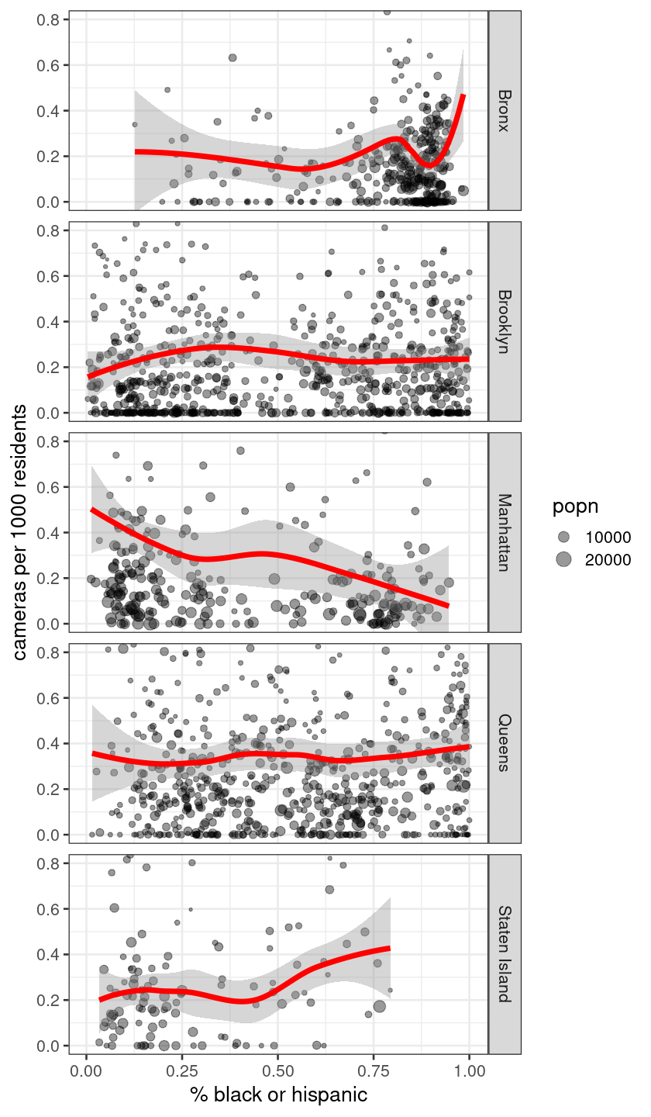

# The distribution of `surv` is definitely non-Gaussian!  
# It has a spike at surv=0, then something like a Gamma distribution, then some outliers.  
# It's not sound to fit a linear regression.  
# That's why I've binarized surv, and fitted a logistic regression.  
  
options(repr.plot.width=12, repr.plot.height=6)  
ggplot(data=df[popn>250 & surv<3]) + geom_histogram(aes(x=surv), bins=60) +  
 ggtitle('Distribution of surveillance level (eff. cameras per 1000 residents)')

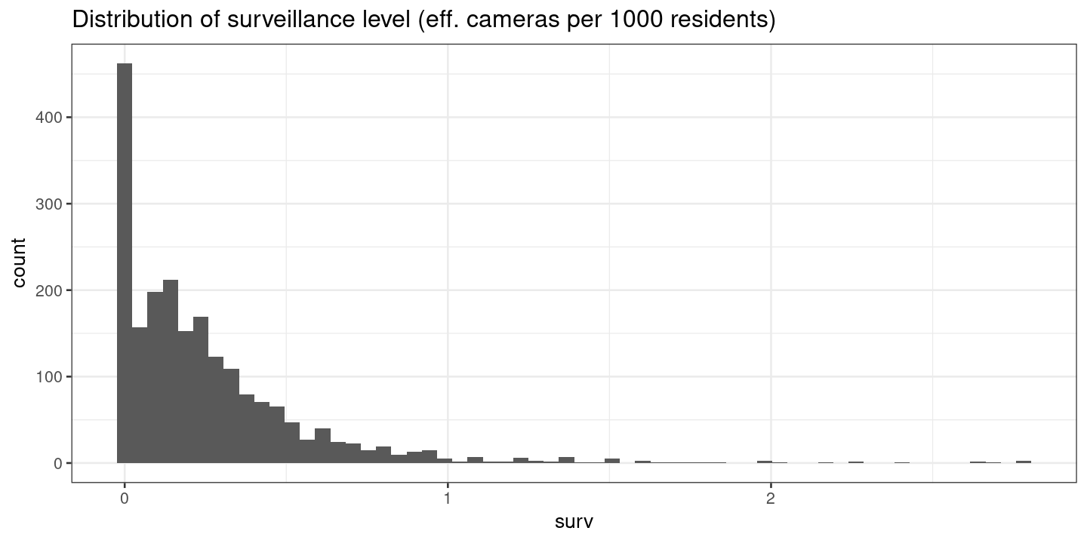

# Map showing relationship between ethnic mix and surveillance.  
# Which census tracts have a high level of surveillance?  
# This is shown superimposed on nonwhite_fraction.  
  
dft <- merge(tracts[,'GEOID'], df, by='GEOID')  
  
options(repr.plot.width=14, repr.plot.height=10)  
  
ggplot() +  
 geom_sf(data=dft, aes(fill=ifelse(popn>250,nonwhite_fraction,NA), alpha=survF), size=0) +  
 scale_fill_gradient(limits=c(0,1), low='darkorange', high='cornflowerblue', na.value='grey90',  
 guide=guide_colorbar(title='nonwhite_fraction')) +  
 scale_alpha_manual(values=c('high'=1, 'low'=0.4), guide="none") +  
 ggtitle('Surveillance level (dark = top tercile of cameras per capita)') +  
 theme_bw(base_size=16) +  
 theme(panel.background = element_rect(fill='azure'))

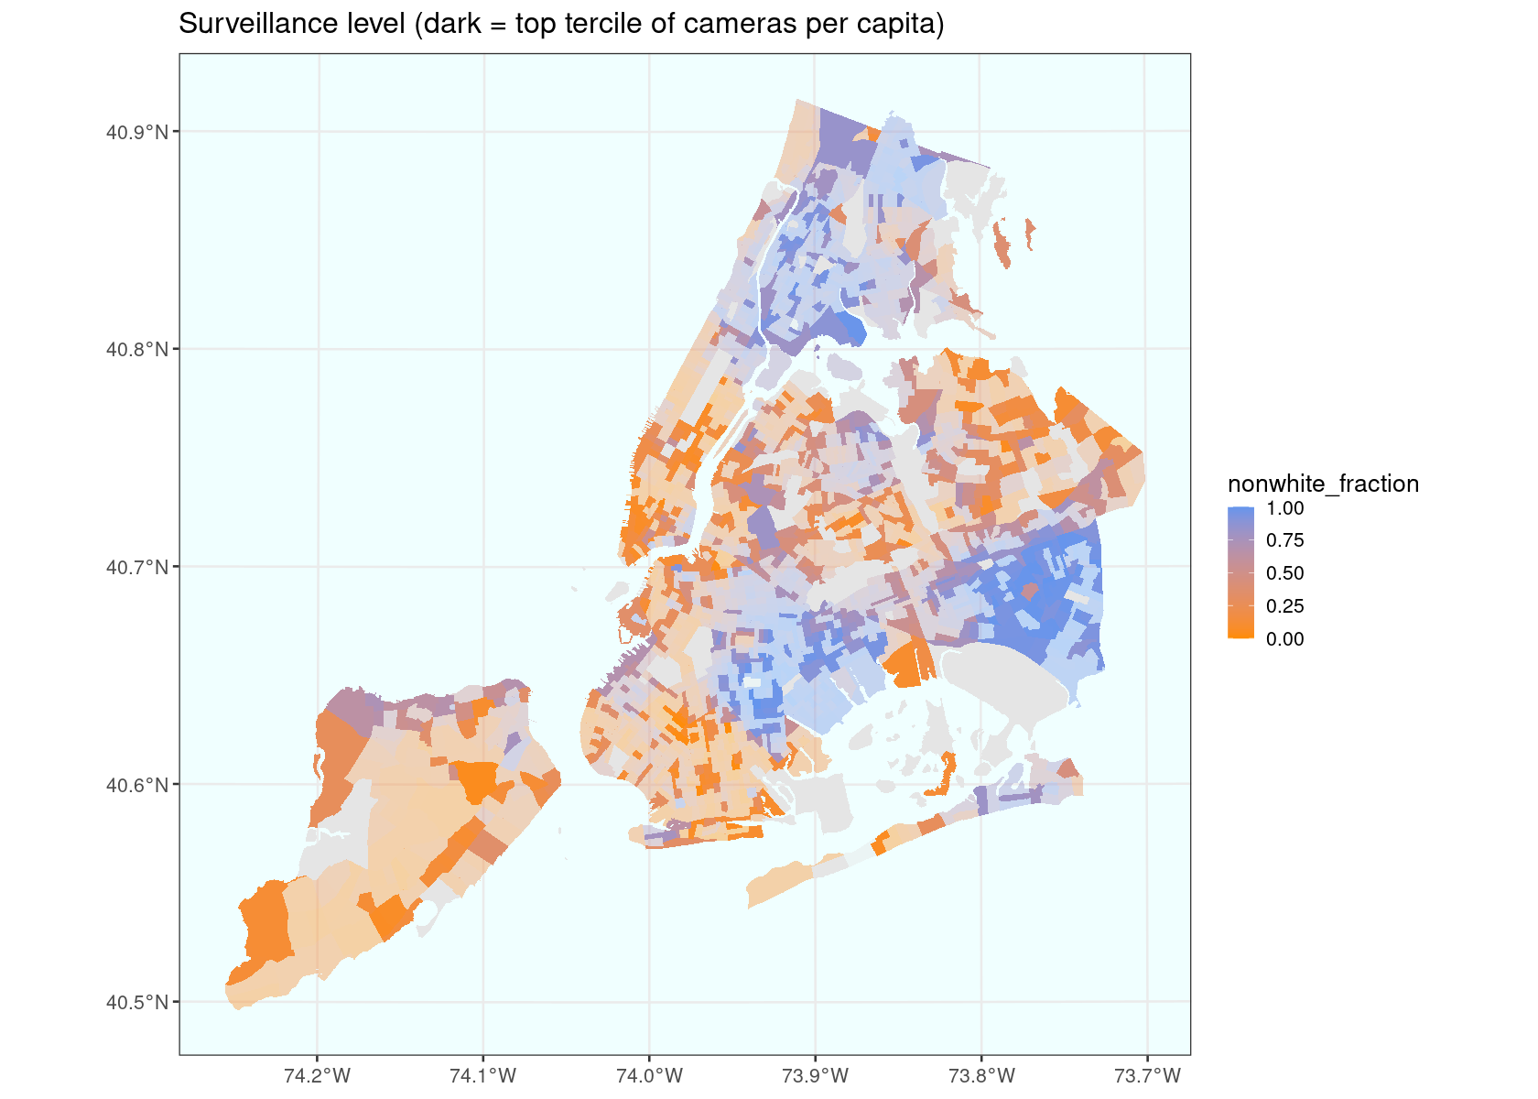

## 4. How else do stop-and-frisk actions depend on surveillance?

We have seen that the stop+frisk rate depends on surveillance level: the higher the surveillance level, the higher the rate. We now investigate this link in more granular detail.

**Suspected crime description.** Does the correlation between stop+frisk rate and surveillance level depend on the suspected crime description? Yes it does: there are some suspected crimes, especially ASSAULT, CPW, ROBBERY, LARCENY, where the stop+frisk rate is highly correlated with surveillance level (making up 71% of incidents). For other suspected crimes, there is no correlation.

**Chance of being found innocent.** Might it be that in areas with high surveillance, the police do more uncalled-for stop+frisks, and hence there are more innocent people stopped? No. There is no correlation between the chance of being found innocent and the surveillance level.

**"Stopped while Black."** We'd expect that the stop+frisk rate should depend on the racial mix: in areas with a higher proportion of Black residents, a higher proportion of stop+frisk incidents are likely to be of Black people. Does this ratio vary according to surveillance level? No, not significantly. (The whopping great fact is that there are many more Black people stopped than other races. This is a property of the stop-and-frisk dataset, and it doesn't seem to be linked to camera surveillance, so it's outside the scope of this study of surveillance.)

### 4.1 Suspected crime description

# Analyse the correlation between num. stops (per capita) and num. cameras (per capita), across census tracts  
# Use 2019 stop-and-frisk data  
  
df <- as.data.table(expand.grid(SUSPECTED_CRIME_DESCRIPTION=unique(sqf$SUSPECTED_CRIME_DESCRIPTION),  
 GEOID=unique(tracts$GEOID)))  
df <- merge(df, as.data.table(sqf)[YEAR2==2019, list(numstops=.N), by=list(GEOID,SUSPECTED_CRIME_DESCRIPTION)],  
 by=c('GEOID','SUSPECTED_CRIME_DESCRIPTION'), all=TRUE)  
df <- merge(df, census[, list(GEOID, popn)], by='GEOID', all=TRUE)  
df <- merge(df, camera_count, by='GEOID', all=TRUE)  
df <- merge(df, as.data.table(st_drop_geometry(tracts))[, list(GEOID,borough)], by='GEOID', all=TRUE)  
df[is.na(numstops), numstops := 0] # for the tracts with no recorded stops  
  
# Surveillance level has some off-the-scale values.  
# A quick fix is to truncate. Another is to regress against rank (survC).  
# Both give similar results here.  
df[, surv := pmin(eff_cameras / popn * 1000, 3)]  
#df[, survC := rank(surv) / .N]  
fit <- lmList(numstops/popn*1000 ~ 1 + surv | SUSPECTED_CRIME_DESCRIPTION,  
 data=df, subset=popn>250)  
  
x <- summary(fit)  
x <- as.data.frame(coef(x)[,,2])  
x$SUSPECTED_CRIME_DESCRIPTION <- row.names(x)  
  
options(repr.plot.width=10, repr.plot.height=8)  
  
ggplot(data=x) +  
 geom_vline(xintercept=0, linetype='dotted') +  
 geom_errorbarh(aes(xmin=Estimate-1.96*`Std. Error`, xmax=Estimate+1.96*`Std. Error`, y=SUSPECTED_CRIME_DESCRIPTION)) +  
 theme_bw(base_size=16) +  
 ggtitle('Corr between stop.rate and surveillance (2019)') + ylab('')

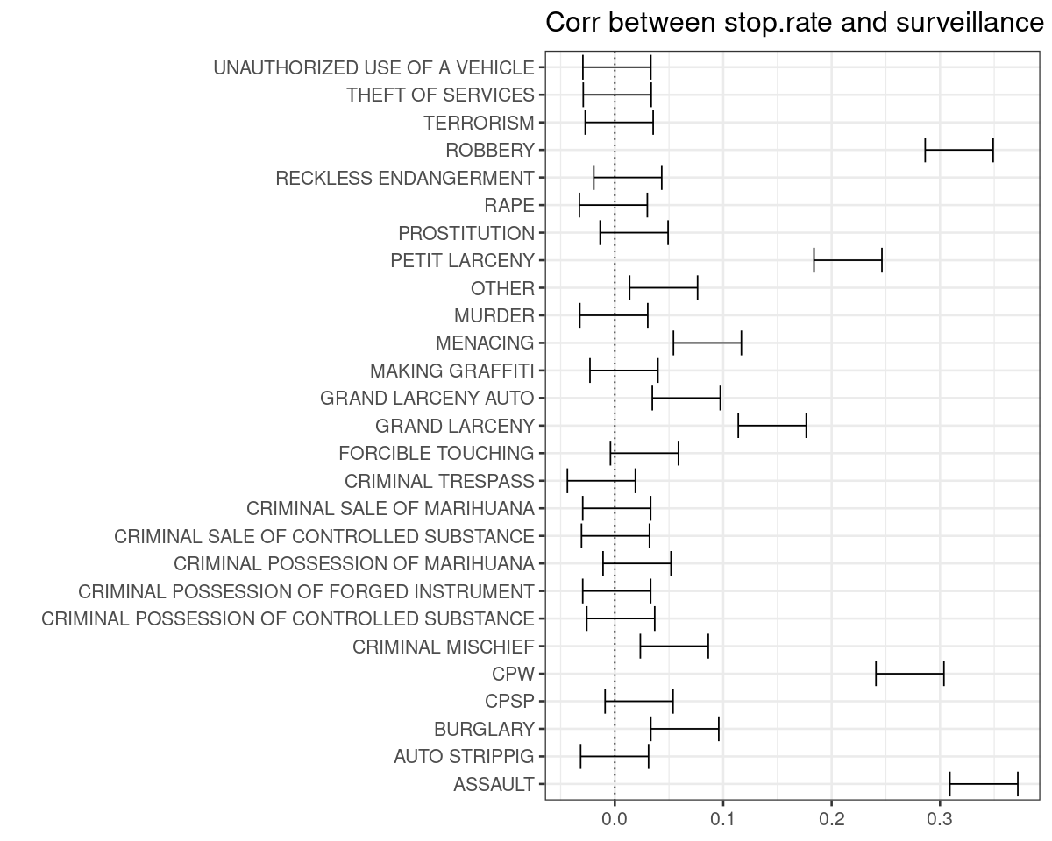

# What fraction of stops (in 2019) are for the five high-correlation reasons?  
  
x <- as.data.table(sqf)[YEAR2==2019, list(numstops=.N), by=list(SUSPECTED_CRIME_DESCRIPTION)]  
x[, corr := SUSPECTED_CRIME_DESCRIPTION %in% c('CPW','ASSAULT','ROBBERY','PETIT LARCENY','GRAND LARCENY')]  
x[, list(numstops=sum(numstops)), by=corr][corr==TRUE,numstops] / sum(x$numstops)

[1] 0.7082993

### 4.2 Chance of being found innocent

# Simple tabulation of #stops, #innocent, per SUSPECT_RACE_DESCRIPTION  
  
df <- as.data.table(st_drop_geometry(sqf))  
df <- merge(df, camera_count, by='GEOID', all.x=TRUE)  
df <- merge(df, census, by='GEOID', all.x=TRUE)  
  
df[, innocent := SUSPECT_ARRESTED_FLAG=='N' & SUMMONS_ISSUED_FLAG=='N' & WEAPON_FOUND_FLAG=='N']  
df[, surv := pmin(eff_cameras / popn * 1000, 3)]  
  
df[, bwh := as.character(NA)]  
df[SUSPECT_RACE_DESCRIPTION=='BLACK', bwh := 'BLACK']  
df[SUSPECT_RACE_DESCRIPTION=='WHITE', bwh := 'WHITE']  
df[SUSPECT_RACE_DESCRIPTION %in% c('BLACK HISPANIC', 'WHITE HISPANIC'), bwh := 'HISPANIC']  
  
df[YEAR2==2019, list(n=.N, nInnocent=sum(innocent), percentInnocent=sum(innocent)/.N*100), by=list(SUSPECT_RACE_DESCRIPTION)][order(-n)]

SUSPECT_RACE_DESCRIPTION n nInnocent percentInnocent  
1 BLACK 7981 5131 64.29019   
2 WHITE HISPANIC 2742 1728 63.01969   
3 WHITE 1215 755 62.13992   
4 BLACK HISPANIC 1127 693 61.49068   
5 ASIAN / PACIFIC ISLANDER 301 214 71.09635   
6 (null) 85 59 69.41176   
7 AMERICAN INDIAN/ALASKAN N 8 5 62.50000

# Does your chance of being found innocent relate to surveillance?  
  
fit <- glm(innocent ~ 0 + bwh + bwh:surv,  
 data = df,  
 subset = popn>250 & !is.na(bwh) & YEAR2==2019)  
summary(fit)

Call:  
glm(formula = innocent ~ 0 + bwh + bwh:surv, data = df, subset = popn >   
 250 & !is.na(bwh) & YEAR2 == 2019)  
  
Deviance Residuals:   
 Min 1Q Median 3Q Max   
-0.6788 -0.6293 0.3544 0.3662 0.4304   
  
Coefficients:  
 Estimate Std. Error t value Pr(>|t|)   
bwhBLACK 0.646634 0.006973 92.736 <2e-16 ***  
bwhHISPANIC 0.631055 0.009780 64.524 <2e-16 ***  
bwhWHITE 0.609913 0.017577 34.700 <2e-16 ***  
bwhBLACK:surv -0.009917 0.015486 -0.640 0.522   
bwhHISPANIC:surv -0.020469 0.022521 -0.909 0.363   
bwhWHITE:surv 0.022974 0.034137 0.673 0.501   
---  
Signif. codes: 0 ‘***’ 0.001 ‘**’ 0.01 ‘*’ 0.05 ‘.’ 0.1 ‘ ’ 1  
  
(Dispersion parameter for gaussian family taken to be 0.2314808)  
  
 Null deviance: 8177.0 on 12857 degrees of freedom  
Residual deviance: 2974.8 on 12851 degrees of freedom  
AIC: 17681  
  
Number of Fisher Scoring iterations: 2

# How about if we restrict attention to suspected_crimes with a known link to surveillance?  
  
fit2 <- update(fit, subset = popn>250 & !is.na(bwh) & YEAR2==2019 & SUSPECTED_CRIME_DESCRIPTION %in% c('ASSAULT','ROBBERY'))  
summary(fit2)

Call:  
glm(formula = innocent ~ 0 + bwh + bwh:surv, data = df, subset = popn >   
 250 & !is.na(bwh) & YEAR2 == 2019 & SUSPECTED_CRIME_DESCRIPTION %in%   
 c("ASSAULT", "ROBBERY"))  
  
Deviance Residuals:   
 Min 1Q Median 3Q Max   
-0.7014 -0.5940 0.3580 0.3838 0.5902   
  
Coefficients:  
 Estimate Std. Error t value Pr(>|t|)   
bwhBLACK 0.64603 0.01279 50.499 <2e-16 ***  
bwhHISPANIC 0.59724 0.01856 32.176 <2e-16 ***  
bwhWHITE 0.51712 0.04018 12.870 <2e-16 ***  
bwhBLACK:surv -0.05235 0.02681 -1.952 0.051 .   
bwhHISPANIC:surv -0.06248 0.04191 -1.491 0.136   
bwhWHITE:surv 0.11626 0.07280 1.597 0.110   
---  
Signif. codes: 0 ‘***’ 0.001 ‘**’ 0.01 ‘*’ 0.05 ‘.’ 0.1 ‘ ’ 1  
  
(Dispersion parameter for gaussian family taken to be 0.2367801)  
  
 Null deviance: 2252.00 on 3685 degrees of freedom  
Residual deviance: 871.11 on 3679 degrees of freedom  
AIC: 5156.9  
  
Number of Fisher Scoring iterations: 2

### 4.3 "Stopped while Black"

# We'd expect that #stops.black / #stops ~ popn.black / popn.  
# Is this relationship impacted by surveillance level?  
# No.  
# (Whether or not I exclude Manhattan, which is a special case.)  
# (I'm using a binarized version of surveillance level, to make it easier  
# to interpret the surveillance:popn.black interaction term.)  
  
df <- as.data.table(st_drop_geometry(sqf))  
df <- df[YEAR2==2019, list(numstops=.N, numstops.black = sum(SUSPECT_RACE_DESCRIPTION=='BLACK')), by=GEOID]  
df <- merge(df, census, by='GEOID', all=TRUE)  
df <- merge(df, camera_count, by='GEOID', all=TRUE)  
df <- merge(df, as.data.table(st_drop_geometry(tracts))[, list(GEOID, borough)], by='GEOID', all=TRUE)  
df[, surv := eff_cameras / popn * 1000]  
  
fit <- lm(numstops.black/numstops ~ 1 + I(popn.black/popn)*I(surv>SURV_THRESHOLD),  
 data = df,  
 subset = popn>250 & borough != 'Manhattan')  
summary(fit)

Call:  
lm(formula = numstops.black/numstops ~ 1 + I(popn.black/popn) *   
 I(surv > SURV_THRESHOLD), data = df, subset = popn > 250 &   
 borough != "Manhattan")  
  
Residuals:  
 Min 1Q Median 3Q Max   
-0.97535 -0.29650 -0.00389 0.17134 0.70482   
  
Coefficients:  
 Estimate Std. Error t value Pr(>|t|)   
(Intercept) 0.29518 0.01482 19.913 <2e-16 ***  
I(popn.black/popn) 0.76378 0.03564 21.433 <2e-16 ***  
I(surv > SURV_THRESHOLD)TRUE 0.01589 0.02159 0.736 0.462   
I(popn.black/popn):I(surv > SURV_THRESHOLD)TRUE -0.01331 0.05049 -0.264 0.792   
---  
Signif. codes: 0 ‘***’ 0.001 ‘**’ 0.01 ‘*’ 0.05 ‘.’ 0.1 ‘ ’ 1  
  
Residual standard error: 0.3027 on 1512 degrees of freedom  
 (311 observations deleted due to missingness)  
Multiple R-squared: 0.3739, Adjusted R-squared: 0.3727   
F-statistic: 301 on 3 and 1512 DF, p-value: < 2.2e-16